* Adding note
  + Login/logout is sitting on top of notes the tab pages
* Allows to create artist and venue without having an account
* No show details
  + (Not sure if this matters)
* Have to go to venues to create a note - it’s not possible to create one from notes tab
* Arrows for artist to scroll through pages don’t work
* When making an account it doesn’t send anything via email about login, etc.
* Superscript link text - word wrap for screen width
* 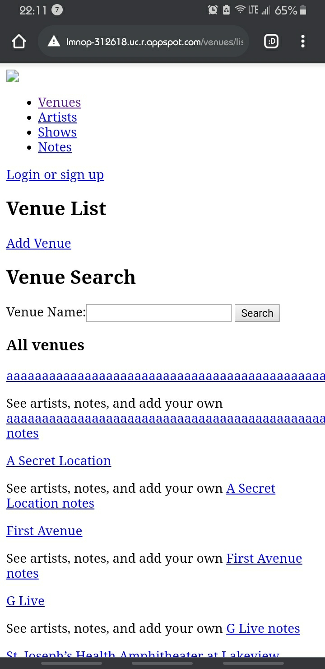
  + Mobile Layout